Chapter 3, Problem 79.

Rework Prob. 3.28 using PSpice.

Chapter 3, Problem 28

Use MATLAB to find the voltages at nodes a, b, c, and d in the circuit of Fig. 3.77.
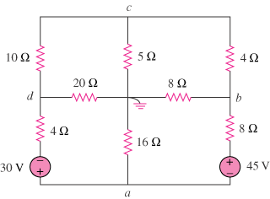
60 V
90 V

Figure 3.77
For Prob. 3.79.

